Matter, Properties and Change
Review for Assessment
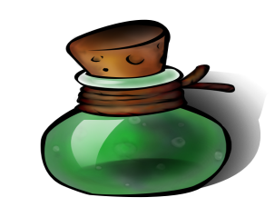

True or False
1. Chemical changes only happen in labs FALSE
2. Chemical changes are irreversible (cannot be undone) TRUE
3. Gases have a definite shape and volume FALSE
4. Solids have a definite shape and volume TRUE
5. All substances melt at the same temperature FALSE
6. All substances boil at the same temperature FALSE
7. Density describes the relationship between volume and mass TRUE
8. Water is the most common solvent TRUE
(Used to dissolve other substances)
9. Most substances contract (become smaller) when heated TRUE
(think cooking a hotdog over a fire)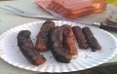
10. Liquids change their shape by flowing TRUE
11. When heat is added, a solid can become a liquid TRUE

Multiple Choice
1. Matter takes up: 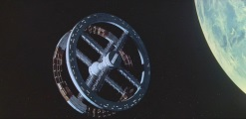
a. space and temperature
b. mass and space
c. heat and temperature
d. space and heat

2. All living and non-living things are made up of a combination of 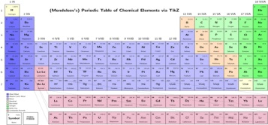
a. liquids
b. metals
c. elements
d. gases

3. Molecules of a substance are farthest apart from each other in which state of matter?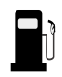
a. gas
b. liquid
c. solid
d. crystal

4. Compared to gases, liquids are not easily compressed because particles of a liquid 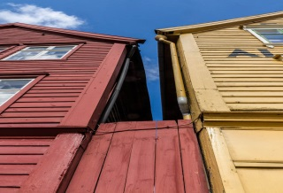
a. are smaller and lighter
b. are moving faster
c. have a crystal structure
d. are closer together

5. All atoms of the same _____________have the same properties
a. mixture
b. element
c. compound
d. solution

6. The temperature at which a liquid becomes a gas is the _________________point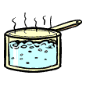
a. natural
b. chemical
c. physical
d. boiling

7. All matter is made up of extremely small particles called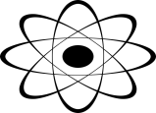
a. nanospecks
b. atoms
c. dust
d. mass

8. The three basic states of matter are: 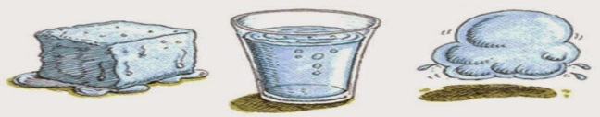
a. solid, gel, liquid
b. air, water, land
c. gel, liquid, gas
d. solid, liquid, gas

9. A stubstance in a solid state has atoms that are: 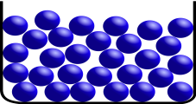
a. packed close together
b. flow in a contained space
c. moving freely
d. large enough to see

10. Most substances can exist as a solid, liquid or gas depending on: 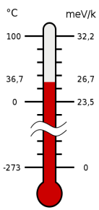
a. volume
b. temperature
c. mass
d. density

11. All substances have properties that can be classified as either:
a. force or motion properties
b. physical or chemical properties
c. hot or cold properties
d. stable or unstable properties

12. Density describes the relationship between: 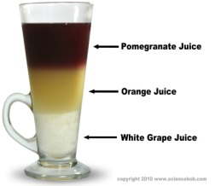
a. velocity and volume
b. volume and mass
c. weight and volume
d. mass and weight

13. Which substance has a definite shape and definite volume?
a. plasma
b. solid
c. liquid
d. gas

14. Chemical changes____________________ 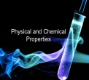
a. have irregular shapes
b. are irreversible
c. happen only in labs
d. made atoms grow

Below is a list of properties. Write a P by the physical, and a C by the chemical properties.
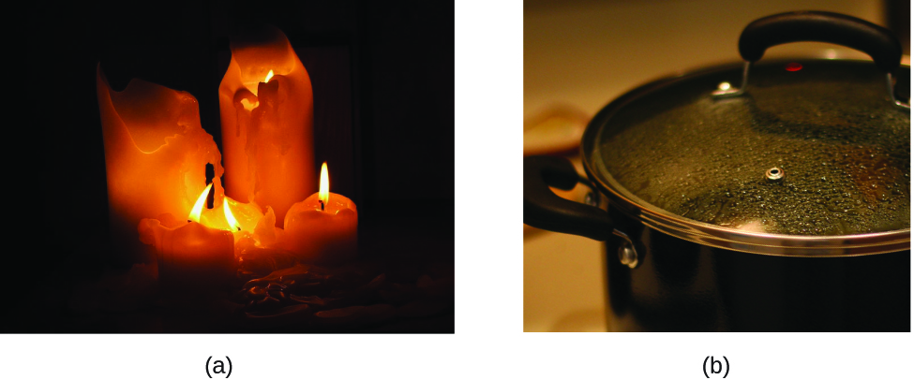
Shape _____ P Density ______P
Fammability _____ C Solubility ______P
Boiling Point _____ P Reactivity ______C

Below is a list of changes. Write a P by the physical changes, and a C by the chemical changes.
Bending a wire _____ P Decomposing leaves ______C
Baking a cake _____C Breaking a glass ______P
Burning wood _____ C Hammering a nail ______P
A nail rusting ______C

Describe how a mercury thermometer records temperature changes, and explain why alcohol is better than water for use in thermometers. (10 points)
(Use and underline the following vocabulary words in your answer: expand, heat, cool, atoms, rise, fall, energy)

